

#### 32X50mm Coreless Brushed Series

**SPECIFICATIONS:**

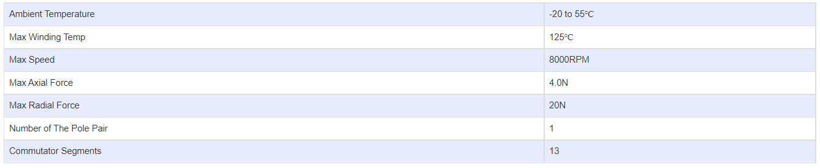

**SUBMODELS:**

*The following are common submodels for the LDO-CL3250 series.*

